**N.NITHIN**

**2420030488**

**SEC-2**

**Task 3**

**Configuration of basic switch setup using Huawei/Cisco network switch using cisco packet tracer.**

**Procedure:**

**Step 1: setting up the network Topology**

1. Open cisco packet tracer 2. Add devices:

* Drag and drop a cisco switch
* Drag and drop two PC’s example PC0, PC1

3. Connect devices:

* Use the connections option to select the copper straight through cable
* Connect each PC to the switch using the FastEthernet ports

(e.g., PC0 – FastEthernet0/1, PC1- FastEthernet0/2) **Step 2: Configuring the Switch:**

1. Open the CLI of the search:

* Click on the switch and go to the CLI tab.
* Enter the following commands:

Switch>enable

Switch#configure terminal

Enter configuration commands, one per line. End with CNTL/Z.

Switch (config) #hostname #1

#1 (config)#interface vlan 1

#1 (config-if)# ip address 192.168.1.1 255.255.255.0

#1(config-if)#no shutdown

#1(config-if)#

LINK-5-CHANGED: Interface Vlanl, changed state to up LINEPROTO-5-UPDOWN: Line protocol on Interface Vlanl, changed state to up

#1 (config-if)#exit

#1 (config)#exit

#1#

\SYS-5-CONFIG_I: Configured from console by console #1#write memory

Building configuration...

[OK]

#1#

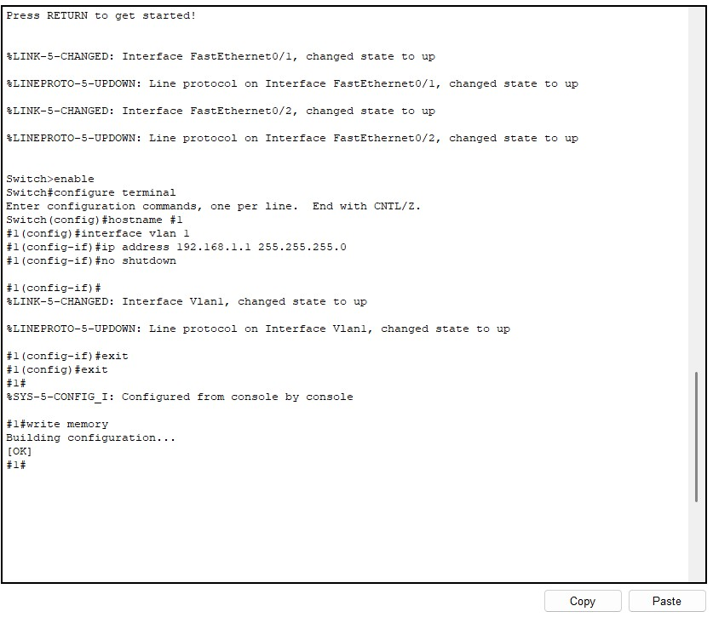

**Step 3: Configuring the PC’s**

1. Assign IP address to PCs:

* Click on each PC and got to the desktop tab
* Open the IP configuration and assign the IP address within the same subnet as the switches VLAN1 interface. For example:
* PC0 IP address: 192.168.1.2, Subnet Mask: 255.255.255.0
* PC1 IP address: 192.168.1.3, Subnet Maks: 255.255.255.0

**Step 4: Testing connectivity**

**1. Ping between PCs:**

* Open the command prompt on one of the PCs
* Use the ping command to check connectivity to the other PC(e.g Ping 192.168.1.3)

